Ronald Reagan – Cold War Hero or Villain

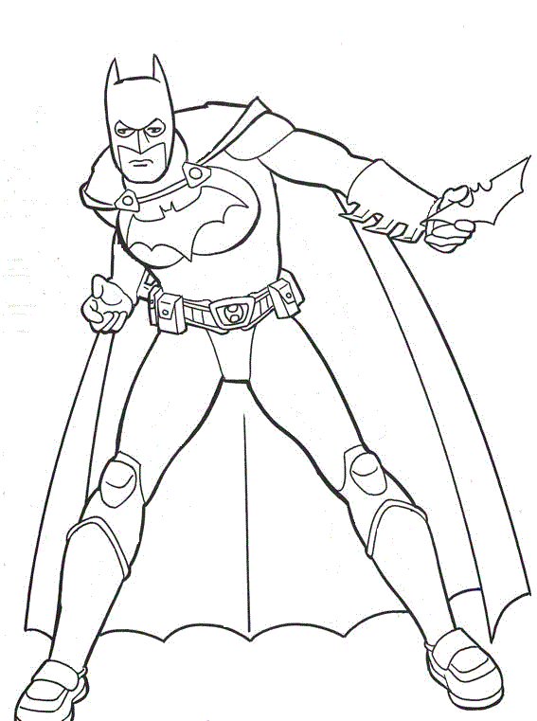
Ronald Reagan is a very polarizing figure in United States political history. You either love him or hate him. There are many arguments for and against him. Within the diagram of Batman below, list in point form the things that prove Reagan was the hero of the Cold War in one colour, and the things that prove he was the villain of the Cold War in another colour. Once completed make a statement as to whether Reagan was a Cold War her or villain (you have to choose a side).

Statement:________________________________________________________________________________
______________________________________________________________________________________________________________________________________________________________________________________________________________________________________________________________________________

