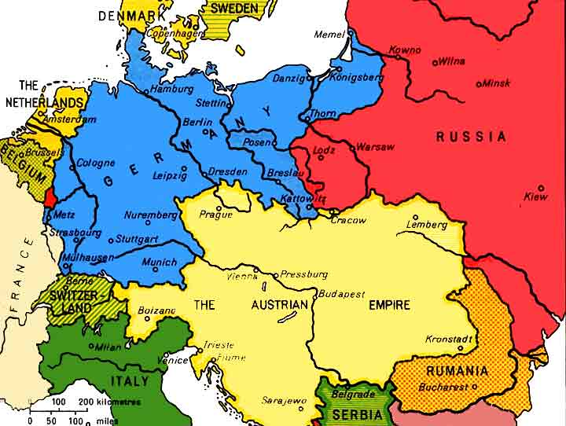
Insert Title Here
Legend: | Items to Include: (Use map on page 2 to assist you)  - Alsace-Loraine  - Czechoslovakia  - Land added to Rumania  - Poland  - Hungary  - Austria | Assignment is assessing the following skills:
  Skills | Self-Assessment (4 – 1) | Teacher Assessment (4 – 1)
  PS & S/S
  HS, C&C


